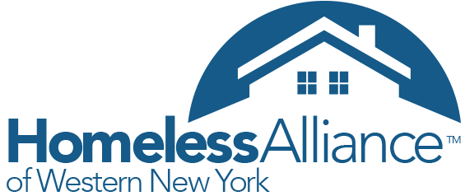

Request for Proposal for creating a Coordinated Entry Evaluation tool and/or conducting the evaluation

RFP Submission Deadline: **March 8th,2019 4:00 pm**

**Introduction -**Homeless Alliance of WNY is a Continuum of Care (CoC) Lead agency for Erie, Niagara, Genesee, Orleans and Wyoming Counties. Our region receives about $12 million Continuum of Care funding from HUD for housing individual and family who experience homelessness. In 2017, our community’s homeless system implemented the Coordinated Entry system, which means people who experience homelessness will be prioritized housing based on their vulnerability and homeless history in order to reduce the homeless time and prevent hard to serve people falling through the crack. This is a revolutionary process compared traditionally to the first come first serve model.

**Purpose:** HUD requires coordinated Entry evaluation to occur annually, focusing on the quality and effectiveness of the entire coordinated entry experience, including intake, assessment, and referral process, for both participating projects and participants.

We are seeking proposals for the development of assessment tools/surveys:

1. Create performance measurements that will use data entered in the Homeless Information Management System(HMIS) to measure the outcomes for the Coordinated entry system as well as outcomes for the coordinated entry lead agencies
2. Review current client survey and provider survey and make suggestions/adjustments.
3. Create an observation evaluation form for evaluators to observe the assessment process at different coordinated entry sites to determine fidelity to the CoC’s policies and procedures and to the training provided.

The second part of the RFP would be to conduct the client and agency surveys on an annual basis. The assessments will be used to improve client service and flow through the homeless service system and to recommend any necessary changes to accomplish this goal.

Participating projects include CoC program and ESG (Emergency Solution Grant) funded shelter and housing projects that are required to participate in coordinated entry, as well as other publicly and privately funded shelter and housing projects serving people experiencing homelessness. Observation evaluation includes 1 Coordinated entry hub location, 2 outreach teams and 16 shelters. Participants are households, including unaccompanied children and youth, experiencing homelessness or who have been connected to housing through the coordinated entry process in the past year. The Homeless Alliance of WNY and City of Buffalo is looking to partner with a University or consultant firms to create an evaluation tool based on the material listed below as well as those who are interested in using this tool as part of the class project to conduct the evaluation and provide us an outcome report annually.

HUD coordinated entry requirements: <https://www.hudexchange.info/resource/5208/notice-establishing-additional-requirements-for-a-continuum-of-care-centralized-or-coordinated-assessment-system/>

HUD coordinated entry management and data guide(Chapter 4):

<https://www.hudexchange.info/resources/documents/coordinated-entry-management-and-data-guide.pdf>

Information related to our regional Coordinated entry:

<https://wnyhomeless.org/continuum-of-care/coordinated-entry/>

Proposal Instruction

As part of your proposal, please address the following:

1. Respondents should outline experience and knowledge in creating and conducting evaluation tools of homeless programs or social services programs.
2. Cost - Breakdown the cost between creating the assessments/surveys and conducting them
3. A time frame for completion of the work, including the time frame of conducting the evaluation if applicable
4. Proposed project outcomes
5. Who will be involved in conducting an annual evaluation
6. Applicant Contact information
7. A List of references

Due to the complexity of the coordinated entry system, we recommend and welcome respondents to contact us before submitting the proposal. All proposals should be received by **March 8th,2019 4:00 pm**. Please contact and/or submit your proposal electronically to:

Kexin Ma

Director of Federal Program

[kexinma@wnyhomeless.org](mailto:kexinma@wnyhomeless.org)

716-853-1101

Mail-in proposals are acceptable by mail to 960 Main Street, Buffalo 14202. But it is not required.

The Homeless Alliance reserves the right to accept or reject any and all proposals in whole or in part.