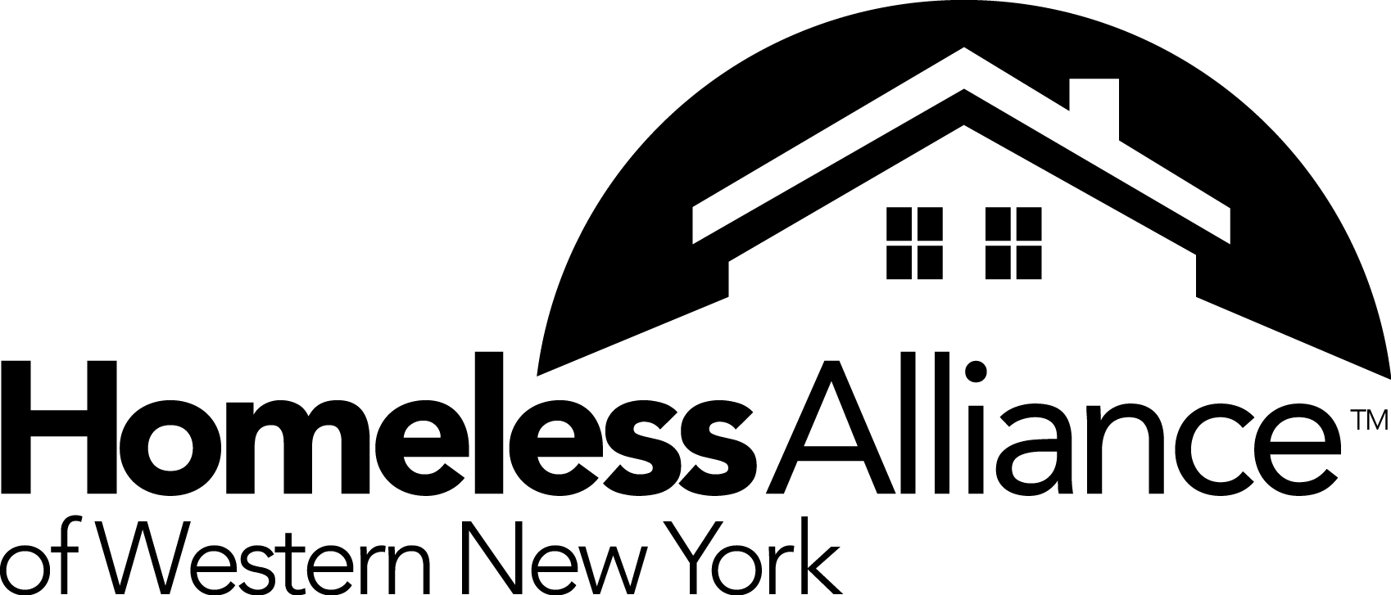

Job Announcement
Continuum of Care Program Monitor
The Homeless Alliance of Western New York (HAWNY), the local Continuum of Care (CoC) for homeless programs in Erie, Niagara, Orleans, Genesee and Wyoming counties has evolved as an organization since its inception in 2005 and is now seeking a Program Monitor to assist in the monitoring and evaluation of CoC program activities.
Job Description: Essential Duties and Responsibilities
- Independently monitor all CoC-funded agencies via site visits to agencies, and run and analyze HMIS reports to answer questions on the monitoring and scoring tools.
- Assist with oversight and review of budget and expenses/vouchers of subrecipients under contract with HAWNY CoC planning grant
- Evaluate and monitor the subreceipient’s objectives and program performance gaps and report on corrective actions needed at least annually
- Implement and participate in program and project monitoring, progress evaluation, survey and program follow up in order to advise and recommend tools and strategies to increase program performances and results
- Work in collaboration to provide technical assistance and capacity building to CoC grantees under contract with HUD to increase program performance
- Document the lessons learned and best practices of the different projects
- Able to learn and train people on a database called Homeless Management Information System (HMIS)
- Assist in the annual process of updating the CoC’s Monitoring and Scoring Tools.
- Develop a full understanding of HUD regulations and System Performance Measurements in order to provide supportive consulting services to our partner agencies.
- Coordinate and assist with the HUD Emergency Solutions Grant (ESG) Administrations
- Any other duties as assigned

Minimum Qualifications: Minimum Requirements for Position
- Bachelor’s degree in Administration, Project Management, Finance or other relevant academic background. A Master’s degree is preferred
- Must be able to understand and analyze data and how it relates to serving clients and successful program performance
- Experience working with non-profit agencies a plus but not required
- Experience working in program compliance is a plus but not required
- Some knowledge of residential housing programs is a plus but not required
- Ability to train and build capacity of others
- Comfortable working with persons from diverse backgrounds
- Must be able to work independently, show initiative, and be a team player
- Must possess a valid New York State Driver’s License and must have access to a motor vehicle to meet transportation requirements within five counties with limited public transportation options

The Homeless Alliance is an equal opportunity employer. All applicants should send a resume, salary requirements and writing sample to: Homeless Alliance of WNY, Attn: Dale Zuchlewski, 960 Main Street, Buffalo, NY 14202. Materials may also be emailed to Zuchlewski@wnyhomeless.org. Please note “Program Monitor” in the subject line of your email. No phone calls, please. Only those applicants considered for the next step in the recruitment process will be contacted.

