Coordinated Entry HMIS Guide

An effective coordinated entry process evaluates and connects those most in need in the community with the most appropriate available resources for their situation as swiftly as possible–the process should be low barrier, housing first oriented, person-centered, and inclusive.

In the coordinated entry process clients are assessed by a standardized survey at the point of entry and are prioritized accordingly. Homeless Management Information Systems (HMIS) are being increasingly used as part of this process. HMIS is used to store assessment data, run reports, and make referrals. This guide will explain the local Coordinated Entry referral process in regards to HMIS.

Making a Coordinated Entry Referral in HMIS
[Emergency Shelters & Outreach Teams]

- Perform a typical HMIS Entry. Include an ROI, Entry Assessment, and any Household members if needed.
  - Clients MUST have an open Entry in the Entry/Exit tab
- In the Assessment Tab, find the “Coordinated Entry for Singles and Households (2016)” assessment and click submit.
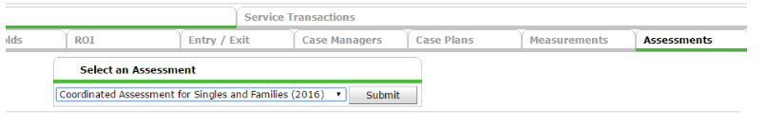
- Make sure the following fields are filled in or updated:
  - Case Manager completing assessment
  - Agency completing assessment
  - Agency/Case Manager contact information
  - Client homeless history
  - Client disability
  - Client current living situation/contact information
  - If the client has had a VI score within the past 3 months and if so, what happened?

- Select the appropriate Scoring Tool and fill out the survey with the client’s answers.
  - Single individuals = VI-SPDAT 2.0
  - Families with children under 18 = VI-F-SPADT 2.0
  - Unaccompanied Youth (18-24) = TAY-VI-SPDAT

- Select the client’s Housing Status.
  - “Yes - meet HUD homeless definition” or “Yes - Do not meet HUD homeless Definition”. This indicates that the client needs assistance for housing and whether or not they are currently homeless and eligible for CoC programs, or looking for other non-CoC housing. We also recommend that you only answer “Yes” if this client can be reached again. If the assessment location is not a shelter, please record client’s contact information in the contact information field above so that housing agencies can contact the client.
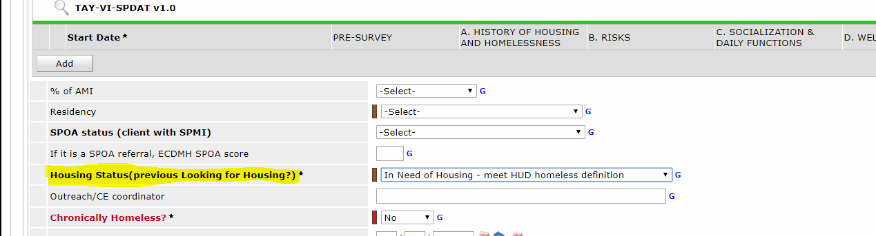

- Add a note in the Case Plan tab or a Date of Contact if you are an outreach team. This allows Coordinated Entry Staff to see if you are actively working with your client and to contact the client if suitable housing is available.

Receiving a Coordinated Entry Referral through HMIS

Permanent Supportive Housing Providers
➔ Referrals will come from Skylar Diamond at Matt Urban
➔ To see where your client stands in the priority list contact Skylar. Please note this is a priority list and not a wait list-therefore the order may change.

Rapid Re-Housing Providers
➔ Referrals will come from Thanh Nguyen at Restoration Society.

Youth Providers
➔ Referrals are handled by the Youth By-Name Committee. Youth are prioritized using the VI score and homeless history as well as number of homeless episodes.

Domestic Violence Providers
➔Domestic Violence Clients are referred by Thanh Nguyen. These clients follow certain security and privacy policies. For more information see the HMIS Domestic Violence Policy and CoC Coordinated Entry Policy.

* Note: Due to visibility and sharing agreements you may not be able to see every client in HMIS. If you want to verify a client is on a coordinated entry list or would like the list for referral purposes please contact HAWNY.

Once a referral is received and accepted, in the client’s “Coordinated Entry for Singles and Households (2016)” assessment change the Housing Status field to “Pending” or “Housed” depending on their current situation. You should also add the date the referral was received as “Referral Date”.

