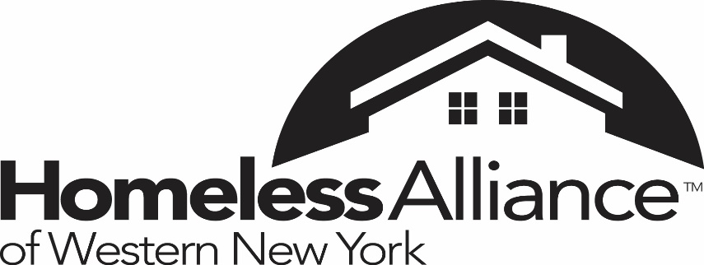

Job Announcement
Program Assistant- Full Time

The Program Assistant will assist in the administration of HMIS activities and the coordination of homelessness alleviation activities in Erie, Niagara, Genesee, Orleans and Wyoming Counties Continuum of Care. The Program Assistant will provide technical assistance to homeless alleviation providers, data analysis and information management for the Homeless Alliance.

Activities Include:
- Assist with HMIS trainings, provide technical support, and maintain database integrity
- Assist with monitoring and tracking service provider's' performance using HMIS and performing site monitoring activities
- Be able to use data base logic to prepare and customize reports from the Homeless Management Information System.
- Assist with user support for HMIS users
- Assist in the research of best practices as defined in the most current literature related to homelessness and poverty
- Organize meetings with service providers and establish relationship with different system partners Assist in the coordination of Continuum of Care activities such as in the fields of health care, employment, education, government, etc.

Qualifications:
- Bachelor’s degree, master’s degree preferred

Skills:
- Basic awareness of homelessness and poverty
- Proficiency in basic quantitative data analysis
- Understanding of query or database logic such as SQL is preferred
- Understanding of basic research principles
- Demonstrated ability to learn programmatic code
- Excellent written and oral communication skills
- General proficiency with computers and Microsoft Office (Word, Excel)
- Ability to collaborate closely with partner agencies
- Public speaking
- Have reliable transportation
- Excellent attention to details and strong written communication skills are required.
- Understanding federal regulations, e.g. Continuum of care regulations, and assist with writing policies and procedures
- Able to take direction and feedback
- Self- motivated and able to work independently

Compensation: commensurate with experience

Please submit cover letter, writing sample, resume and salary requirements to the Homeless Alliance by email to Dale Zuchlewski, zuchlewski@wnyhomeless.org. No phone calls, please. The Homeless Alliance of Western New York is an Equal Opportunity Employer (EOE). This announcement may be used to fill other positions at the Homeless Alliance.

