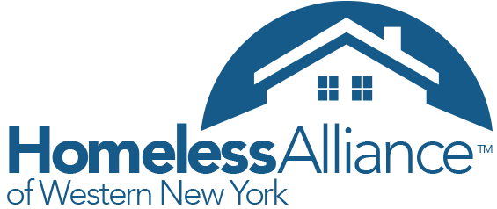
August 8/2015

Thanks again to everyone who was able to attend the GOW Point-in-Time Committee Meeting on 8/17. We discussed many important topics needed to make this summer's point-in-time count accurate. Here are some of the highlights:
- Changed PIT date (Sept 14-18).
- Identified important known locations to find clients in your Genesee County (Lehigh Bridge, Donation Containers, parks).
- Identified important partners in Genesee County: school districts, parks department, All Babies Cherish, GCASA, Habitat for Humanity
- Edited PIT questionnaire.
- Divided follow-up responsibilities in Genesee County (please forward questionnaire and instructions to partners)
- Outreach incentives (coffee and donuts(
NEXT STEPS needed to make this PIT count a success:
- Volunteers needed to do outreach (please contact HAWNY for more information)
- Identify known locations for Orleans and Wyoming Counties
- Training Phone conference call (Wednesday 9/9)
Attached to this e-mail includes identified service organizations, outreach safety tips, instructions, the most recent school district data related to homelessness and the edited questionnaire being used. Additionally, here is a resource map showing known service providers, and possible known locations.

Once the PIT 5-days is complete, please followup with your community partners and return all questionnaires to HAWNY office. There will be a follow-up reminder e-mail.

**Additional suggestions and involvement with outreach is still needed and encouraged. Contact Andrew Dearing at HAWNY to see how you can help or if you have additional questions.

REMINDER: There is HMIS training on September 26th 10AM at 113 Batavia NY for Orleans, Genesee, and Wyoming Counties.

