2014 HUD Data Elements and HMIS Changes
New Workflow
- Search screen---search with Name, SSN. Also please answer all the questions on the search screen.
- Single clients-- go directly to ROI, then to Entry/Exit. Complete all information in the Entry as opposed to the client profile tab.
- Households—go directly to household tab, then ROI, then Entry/exit. Complete all information in Entry as opposed to household or client profile tab.
- Updates will no longer take place on the client profile page. All updates will be done on the ‘interim’ tab. This is located on the entry/exit. Click on interim and select ‘update’ to update any client information.
- Annual Assessment
- Interim Review utilized to record updates and the Annual Assessment. Updating on the client profile page will no longer be valid.
- For clients who stayed one year or longer, they are required to complete the annual assessment 1 year from client anniversary+/- 30 days for APR purpose.
- Interim Review is located at the Entry/Exit tab. Make sure to select Annual Assessment under Review Type for APR purposes.
- Bowman is working on creating an alert to indicate when annual assessment is due, but this is not available yet. You can create a case plan, and a reminder will be set up that way.

HUD Verification: This is a new sub assessment for Disability type, Income, Non cash benefits, and Health insurance. You must go into each sub assessment and select ‘yes’ or ‘no’ for each option. Will show on the screen. Once completed, it will have a green check mark.

Veteran Status is now part of the client record. It is shared amongst all users, and is to be completed only once per client. Please check the accuracy of veteran question with detail after Oct. 1. HMIS will take the most recent answer to this question, not what you answered individually. The Client Consent must be updated to include veteran status. You can download the updated client consent from our website or through bas-net news

Health insurance is a new data element. Please note that Medicaid/Medicare are no longer in the non- cash benefits sub assessment, and are now located in the health insurance sub assessment.
Children’s Income and Non-Cash benefits are now recorded under the Head of Household’s income and non-cash benefits. If there are multiple adults in the same household, they should keep their incomes and benefits separate. Health insurance is still required to be recorded for each client, including children. When a child ages into adulthood, their information should be updated to include their income and benefits.
CoC Location Code
You will need to select our CoC Location code for every client. Our CoC location code is NY508. It says NY508 Erie/Niagara.

Length of time on Street, Emergency Shelter, or Safe Haven. This is a new element.

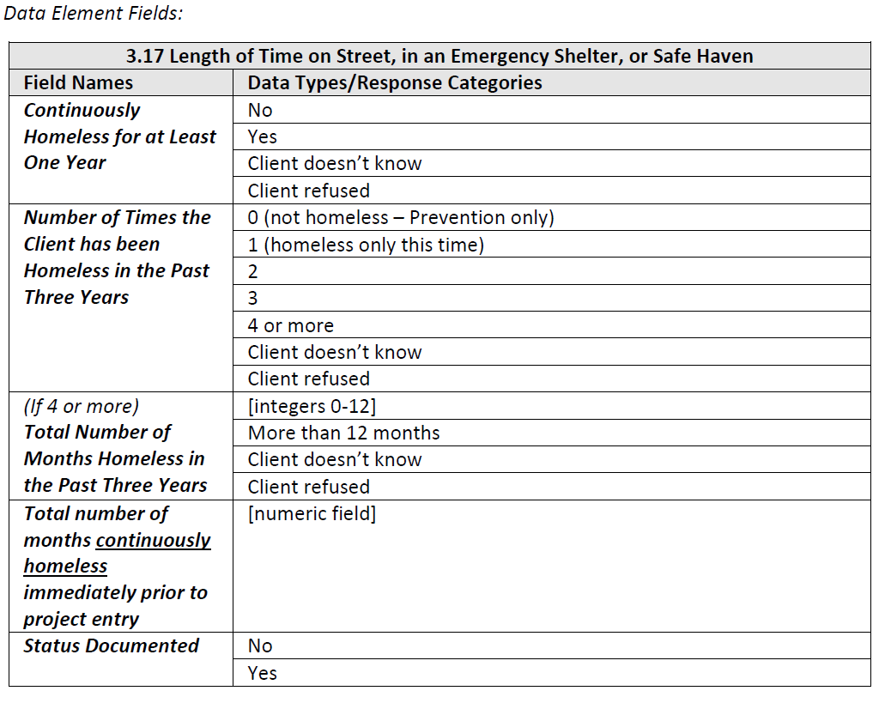

Response Category Descriptions:
• Continuously homeless for at least one year: The client has been homeless and living or residing in a place not fit for human habitation, an emergency shelter, and/or a Safe Haven continuously for at least one year as of the date of project entry. Stays in institutions of 90 days or less do not constitute a break in homelessness, provided the client was homeless prior to entering the institution.
• Number of Times the Client has been Homeless in the Past Three Years: Enter “0 (not homeless – Prevention only)” if the client did not experience homelessness in the past three years, including today. For example, the client is entering a homeless prevention project and has not been homeless in the past three years. If the client is entering a housing project for the homeless, “0 (not homeless – Prevention only)” may not be used. Enter “1 (homeless only this time)”, “2”, “3” or “4 or more” based on the number of times the client was homeless and living or residing in a place not fit for human habitation, an emergency shelter, and/or a Safe Haven over the past three years. Count an episode of homelessness that begins as of project entry. For example, a client is staying with a friend, is asked to leave, and then enters an emergency shelter. The client had not previously stayed on the streets or in a shelter, so the number of times homeless in past three years would be “1 (homeless only this time)”.
• Total Number of Months Homeless in the Past Three Years: If the number of times the client has been homeless in the past three years is 4 or more, count months the client was homeless and living or residing in a place not meant for human habitation, an emergency shelter, and/or Safe Haven in the past three years. Any single day or part of a month spent homeless should be counted as one month.
• Total Number of Months Continuously Homeless Immediately Prior to Project Entry: Indicate the number of months the client has been continuously homeless including the day of project entry. For partial months, 1 day to 30 days = 1 month. For example, a client is living on the street from mid-July to the day the client enters emergency shelter on August 5th. This would count as two months.
• Status Documented: Indicate if there is documentation in the client’s paper file or in the HMIS of the client’s length of homelessness (either continuously homeless, the number of times homeless, or the number of months homeless in the past three years).

Workflow Diagram

