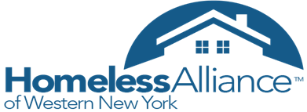

June 19, 2019
Agenda
- Introductions
- Guest Speaker – James McNeil, Youth Services Coordinator, Salvation Army Buffalo Area Services
- System Performance Measurement discussion and success stories – Joelle Dyer and Kexin Ma
- Community Announcements
- Adjournment

Next Meeting: 8/21/19 at 3pm at the Salvation Army Building, 960 Main Street, Buffalo NY 14202.

