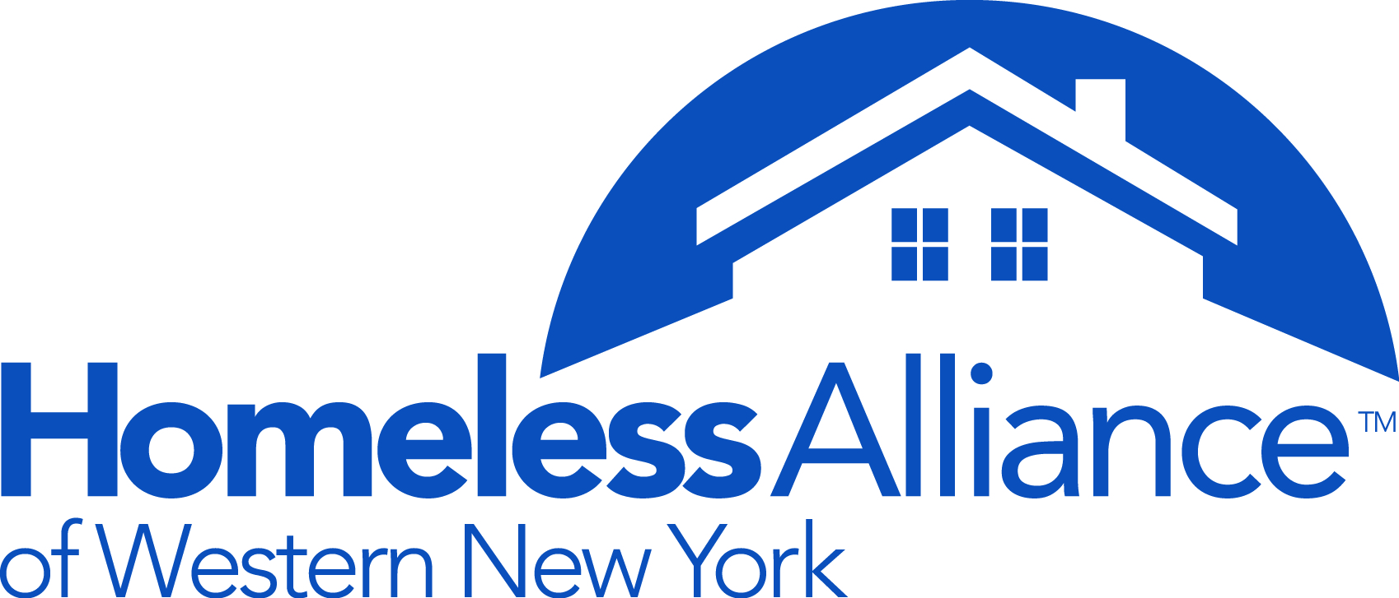

**HAWNY 2015 LUNCHEON AWARD NOMINATION FORM FOR THE FOLLOWING AWARDS CATEGORY:**

1. **Monsignor Henry Gugino Organizational Service Award**

Named after Monsignor Henry Gugino, a passionate advocate for the poor who served in a director’s capacity at Catholic Charities for over 20 years, the Gugino Organizational Service Award recognizes the achievements of an agency or program that has provided exceptional service to homeless persons or toward the elimination of homelessness at its root causes in the past year.

1. **Killian Vetter Individual Achievement Award**

One of the founders of the Erie County Commission on Homelessness and a longtime advocate for social justice, Killian Vetter passed away on October 25, 2008. This award recognizes the hard work, dedication, and special achievement of an individual who has worked on behalf of homeless and low-income persons. Individuals considered for the award may be professional service providers, volunteers, government officials, or any other person actively engaged in work to benefit homelessness persons or working toward the elimination of homelessness at its root causes.

1. **Unsung Hero**

This award would recognize someone who has done a considerable amount of work for the homeless working diligently behind the scene.

1. **Media Award**

The media award honors journalists or organizations for their fair and accurate reporting of the homeless population and the issues that affect their lives.

1. **Other**

If you have a suggestion for an award, please send the homeless alliance your idea.

Examples: Inspiring Public Official, Outstanding Collaborative Effort.

**Nominator Name: ______________________________________________________________**

**Agency Name: _________________________________________________________________**

**Phone:_______________________________________________________________________**

**Name of Nominee: ______________________________________________________________**

**Category: _____________________________________________________________________**

**Reason for Nomination**:

_____________________________________________________________________________________

_____________________________________________________________________________________

_____________________________________________________________________________________

_____________________________________________________________________________________

_____________________________________________________________________________________

_____________________________________________________________________________________

_____________________________________________________________________________________

_____________________________________________________________________________________

_____________________________________________________________________________________

_____________________________________________________________________________________

May we contact you for additional Information? Yes _____ No ______

Nomination Forms are due November 16 at 5pm to:

Homeless Alliance of WNY

960 Main St.

Buffalo, NY 14202

Fax: 853-1750

Email: smith@wnyhomeless.org@wnyhomeless.org