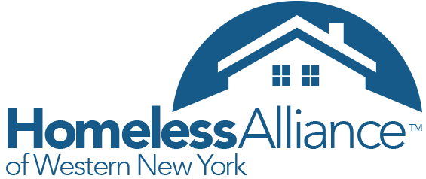

HMIS Data Entry and Timeliness Policy

Participating agencies must accurately enter data within 72 hours of entry/exit of the program or when provided with updated information. The Homeless Alliance of WNY will monitor agencies remotely to ensure these data completeness and timeliness policies are being followed.

All of the documentations related to the HMIS and CoC policies and procedures are available on our website, www.wnyhomeless.org

Reporting Process

- Every month the ServicePoint User Last Login Report will be run. This report shows all user activity for agencies in HMIS. All users must be actively engaged in using HMIS. New Users to HMIS will be subjected to higher degree of scrutiny within their first month of receiving a license to ensure their compliance and familiarity with HMIS regulations.
- All projects will also be subjected to random user audit reports to ensure that users are using HMIS correctly
- Client Served Reports:
  - For Emergency Shelters, SSO, and Transitional Housing Projects we will run random monthly Entry/Exit reports. If the total number of clients served is off by 25% from the previous year, an inquiry e-mail will be sent to the Agency Administrator. The Agency Administrator must write back within 48 hours with an explanation as to why the reported number of clients served does not match the typical number of clients served in previous years.
  - For PSH projects we will conduct monthly random checks on a rotating basis. This will consist of Entry/Exit reports of your grant year and spot checking of client files in HMIS to see if interim reviews and ROI’s are being utilized. The Agency Administrator must write back within 48 hours with an explanation as to why the reported number of clients served does not match the typical number of clients served in previous years and explain any discrepancy in client files.
- For any agency that has not logged in within the past month, an informal inquiry e-mail will be sent to the Agency Administrator. The Agency Administrator must write back within 48 hours as to why ServicePoint has not been utilized within the report time period.
  - All agencies must login to ServicePoint within the last two calendar months. If there has not been any user logged in within 2 calendar months, a more formal disciplinary action will be taken.

Disciplinary Process

Each agency must be logged in and actively using ServicePoint. The following describes the disciplinary process for not following the agreed upon terms:
- If not logged in within the last calendar month, an informal inquiry e-mail will be sent. Agency administrator must respond within 48 hours.
- If not logged in within the last two calendar months, an official warning letter will be sent to the Agency Administrator and Executive Director. An official warning letter will also result in a deduction of points for your HMIS score for the CoC competition.
- If an Agency receives two warning letters within the calendar year, this will result in a 0 for your HMIS score for the CoC competition.
- If Agency is still not utilizing ServicePoint after two warning letters in a calendar year, a meeting with the Executive Director, Agency Administrator, and applicable HAWNY staff will take place to discuss further discipline. Further discipline can include loss of federal CoC funding.

