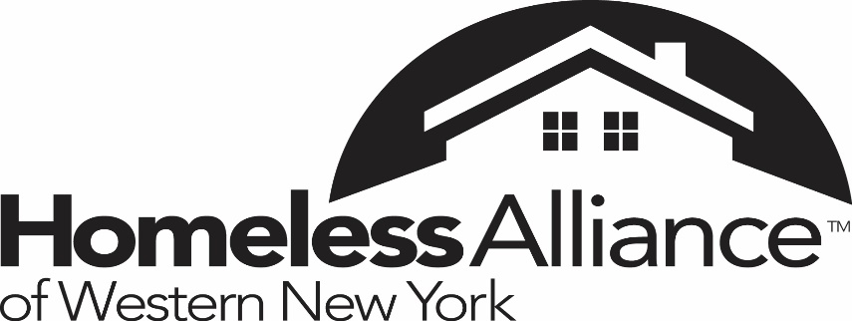

HMIS Participating Agencies

211
Altamont
Back to Basics
Belmont Housing Resources for WNY
Best Self Behavioral Health
Blue Cross Blue Shield
Buffalo City Mission
Buffalo Federation of Neighborhood Centers
Buffalo Urban League
Catholic Charities
Cazenovia Recovery Services
Chautauqua Opportunities
City of Buffalo
Compass House
Community Missions Inc.
Niagara County Child and Family Services
Erie County Department of Mental Health
Erie County Department of Social Services
Erie County Medical Center
Evergreen Health Services
Family Promise
Friends of the Night people
Genesee County DSS
Genesis House
Gerard Place
Grace Point
Harvest House
Heart Love & Soul
Hispanos Unidos De Buffalo
Homeless Alliance of Western New York
Housing Opportunities Made Equal
Housing Options Made Easy
Kalieda Health
Little Portion Friary
Living Opportunities of DePaul
Little Portion Friary
Matt Urban Hope Center
Neighborhood Health Center
Neighborhood Legal Services
Niagara County Dept. of Social Services
Niagara Gospel Mission
Niagara Falls Memorial Medical Center
Olmsted Center for Sight
Peaceprints of WNY
Path Stone Corp.
Orleans County DSS
St. Francis of Assisi
Salvation Army
Southern Tier Environments for Living
Saving Grace Ministries
Save The Michaels of the World
Spectrum Human Services
Temple of Christ
Teaching and Restoring Youth
The Restoration Society Inc.
Transitional Services Inc.
United Church Home Society We Soldier On
WNY Independent Living
Wyoming County DSS
WNY Veterans Housing Coalition
Veteran’s Administration
Veterans One Stop Center
Veterans Outreach Center
YWCA of the Tonawanda’s
YWCA of Western New York
YWCA of Niagara
VIVE-Jericho Road

