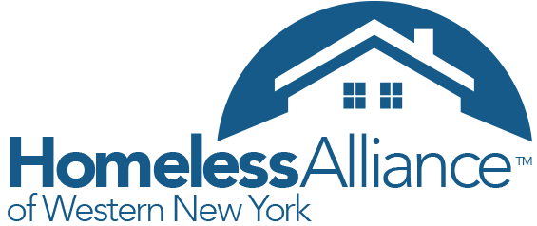
October 28th 2015
We had a lot of great discussion about the strengths, weaknesses, opportunities and threats each community is facing when serving the homeless and at-risk. A summary of what was discussed is attached to this email.
To further identify the needs and priorities for the GOW area, please take a moment to rank identified opportunities through this ONE QUESTION SURVEY by November 6th. (1 "highest priority" to 12 "lowest Priority")
Here is a brief update:
Point- in-Time Count
Thank you to everyone who helped gather data for the Summer 2015 PIT count. Attached is a summary of the Summer 2015 PIT count and presentation for the GOW meeting. Keep in mind that HAWNY is planning another count on the third Wednesday of January (1/27) for the entire 5 county CoC. It is the official count required by HUD. Similarly, we will be asking for PIT Committee members from the GOW Region to help plan/coordinate.
NOFA & RFP update:
As many of you know, we are in the process of preparing applications for the annual HUD Federal Continuum of Care Program funding competition. Applications from the 5 county region have been submitted to HAWNY and ranked by a selection committee based on a HUD point system and local/national priorities. The GOW has 2 programs competing; 1 renewal program (Orleans Pathstone Vision) and 1 new program (Independent Living -GOW- Rapid Rehousing).
HAWNY is no longer accepting applications and final submission to HUD is November 20th, 2015. A complete list of rankings and projects can be seen on HAWNY's website.

The next GOW meeting will take place 10AM Tuesday December 9th at 113 Main Street, Batavia NY(Independent Living of Genesee Region). This meeting accounts for November and December.

