Austin-Travis County YHDP Outcome Tracking: Data Entry

The Austin-Travis County questions refer to questions that were developed by Continuum of Care TX-503 Austin/Travis County in order to assess outcomes for youth experiencing homelessness. Specifically, the questions measure progress related to the establishment of permanent connections, education and employment, and socio-emotional well-being.

Entering and tracking outcome data derived from the Austin-Travis County standards is handled in a unique manner. This guide will show you how to enter and update this data using the HMIS goal tracking system.

The Austin-Travis questions are part of the initial entry assessment that is filled out for every client who is enrolled in a YHDP project.

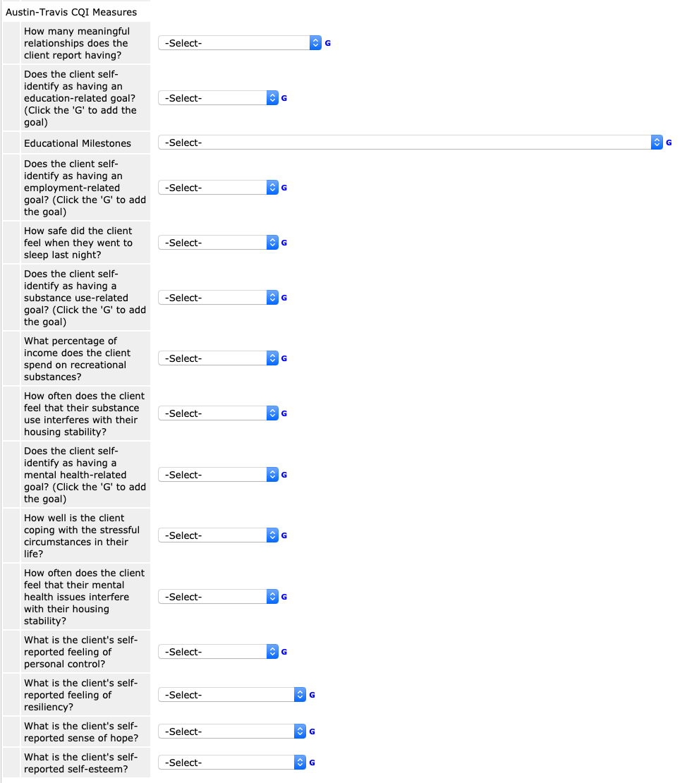

Every Austin-Travis question should be answered during the initial assessment. Updates to these answers should be entered while doing interim assessments.

Some of the questions have simple drop-down lists from which to choose answers. For these cases, nothing special needs to be done.

Other questions require a goal to be added and tracked in order for the measures to be calculated correctly. These questions will have an additional note in the question text that says “(Click the ‘G’ to add the goal)”.

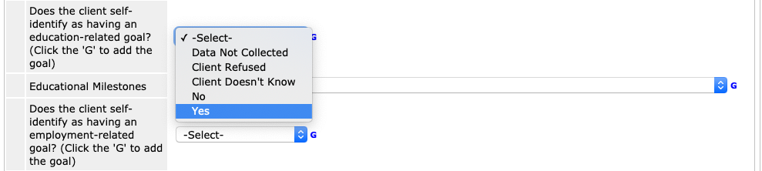

When a client answers yes to one of these questions, choose “Yes” from the drop down menu and then click on the ‘G’ next to the drop down menu. This will open a pop-up dialog box where the new goal can be created.

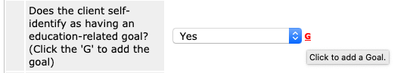

The dialog box will need to be filled out with details related to the new goal.

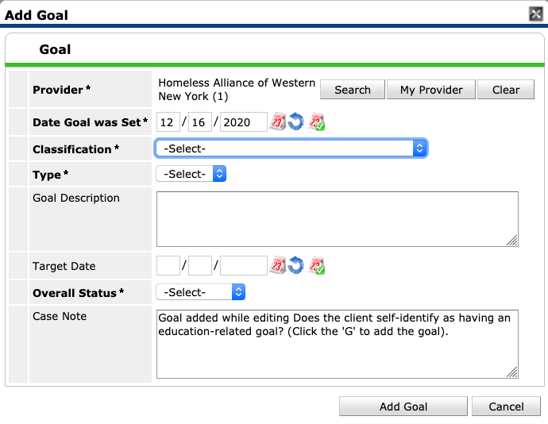

For YHDP programs, you should only choose a goal classification that uses the ‘YHDP’ prefix. Otherwise, they will not be included in subsequent reporting.

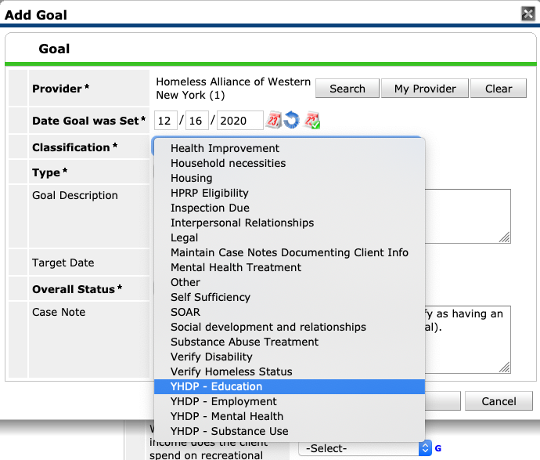

After doing data entry, the goal should look similar to the following.

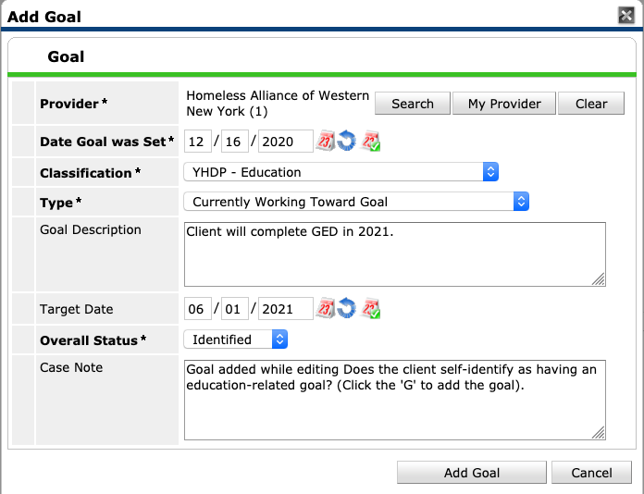

Notice that the following fields have been filed out:
- Date Goal was Set
- Classification
- Type
- Goal Description
- Target Date
- Overall Status

Once these fields have been filled out, click ‘Add Goal’ to save your work.

Over time, clients will make progress on goals, fully or partially achieve their goals, and in some cases will abandon their goals. These updates need to be entered into HMIS.

To enter updates, navigate to the ‘Case Plans’ tab of ClientPoint and click on the pencil icon next to the goal that needs to be updated.

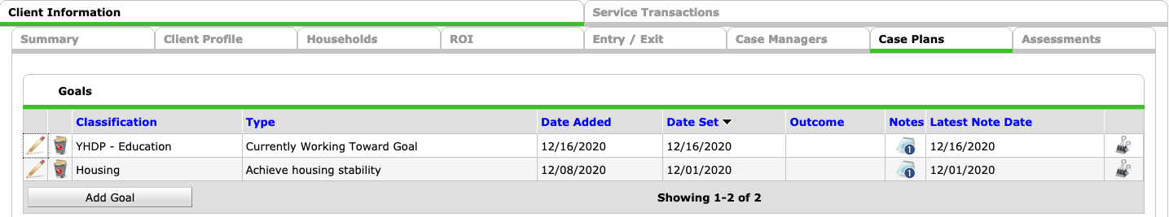

A pop up menu will appear that shows the current status of the goal. Initially, it will include the data that was entered when the goal was created.

You are free to add updates and case notes at any time, but from a reporting perspective, it is important to enter updates when a client has fully or partially achieved a goal, or when a goal has been abandoned.

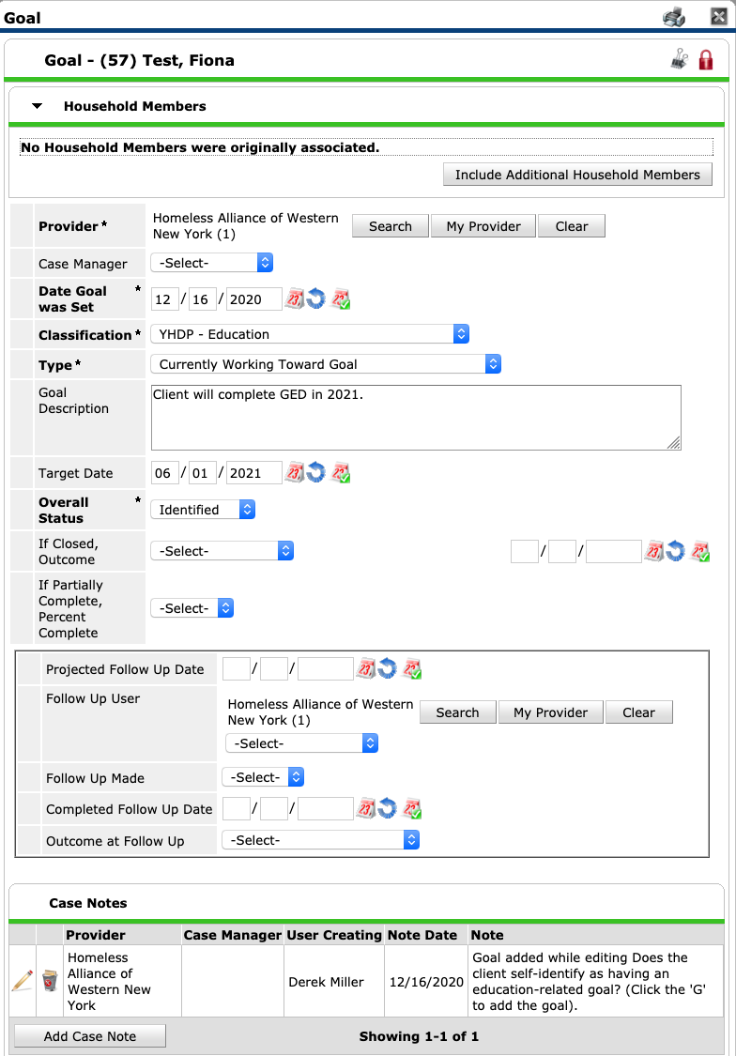

When a goal has been fully achieved, the following fields should be updated:
- Type: ‘Successfully Completed Goal’
- Overall Status: ‘Closed’
- If Closed, Outcome: ‘Achieved’ + Date

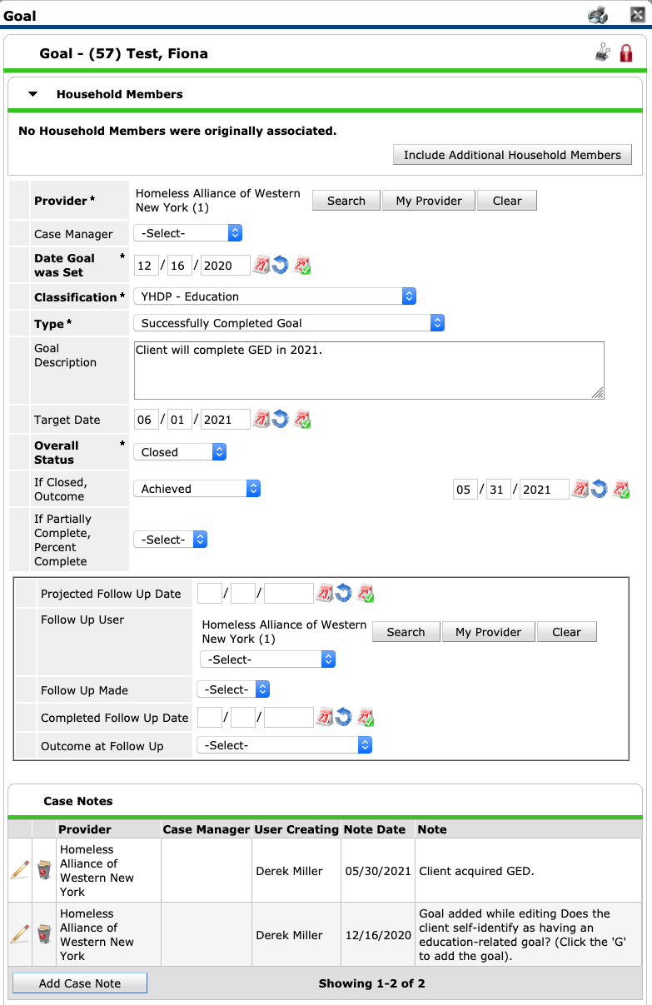

When a goal has been partially achieved, the following fields should be updated:
- Type: ‘Successfully Completed Goal’
- Overall Status: ‘Closed’
- If Closed, Outcome: ‘Partially achieved’ + Date
- If Partially Complete: Percent Complete

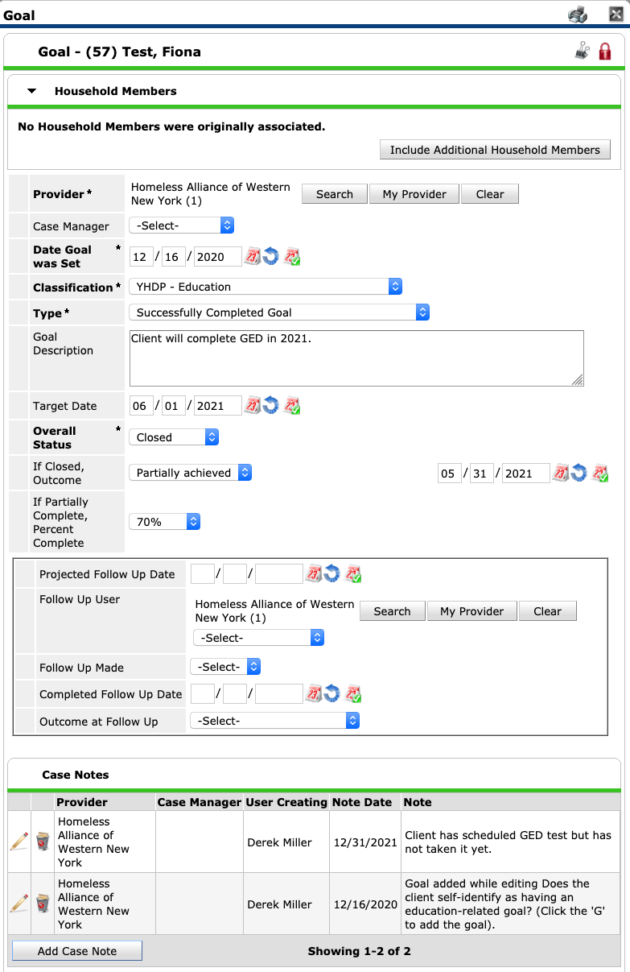
When a goal has been abandoned, the following fields should be updated:
- Type: ‘Stopped Working Toward Goal Prior to Completion’
- Overall Status: ‘Closed’
- If Closed, Outcome: ‘Abandoned’ + Date

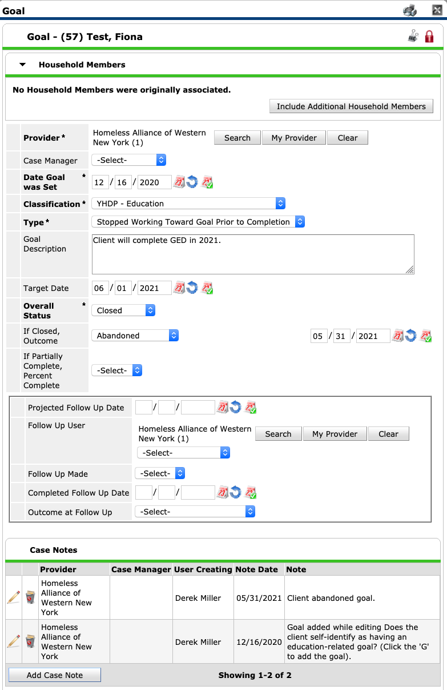

Workflow Bonus Tip:
This is not required, but may help with workflow.
While updating a goal, you can add a ‘Projected Follow Up Date’. If you add a future date here, your HMIS home screen will alert you when the goal needs to be updated.
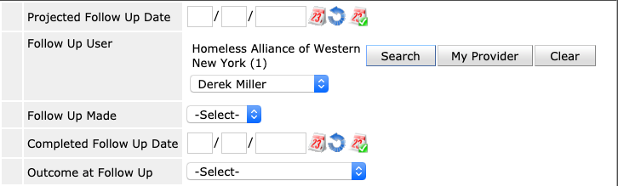

The prompt will appear in the ‘Follow Up List’.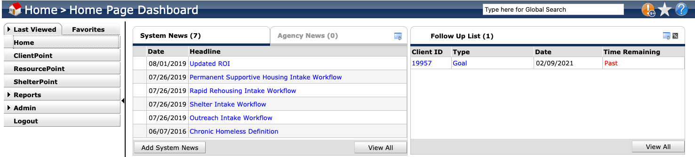

Note that this cannot be done when first creating a goal from within an assessment. In order to use this feature, you need to navigate to an existing goal on the ‘Case Plans’ tab.

